Lesson 5 Demo 5: Create an Overlay Network

This section will guide you to:

* Create an overlay network in a Docker swarm cluster
* Create a replicated service to establish communication between service tasks

**Step 1:** Check the network drivers on the manager and worker nodes of the swarm cluster

* On the **master** tab, list all the networks and check the **Driver** type of swarm cluster

*sudo docker network ls*

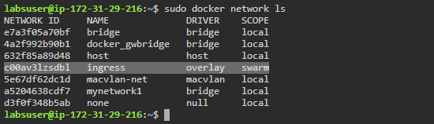

**Note:** Notice that the **Driver** type of swarm cluster is **overlay** and its name is **ingress.**

* Click on the **worker1** tab and navigate to the newly opened tab of worker1 node

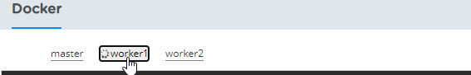

* On **worker1** node, list all the networks and check the **Driver** type of swarm cluster

*sudo docker network ls*

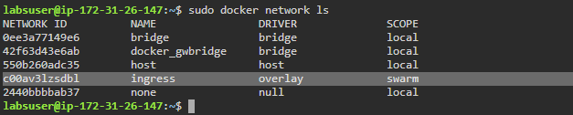

**Note:** Notice that the **Driver** type of swarm cluster is **overlay** and its name is **ingress.**

**Note:** Navigate back to the **master** tab to run commands on manager node

**Step 2:** Create an overlay network and run a replicated service on it

* Use the following command to create an overlay network

*sudo docker network create -d overlay nginx-net1*

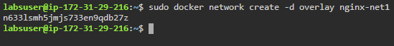

* Create a replicated service with five replicas connected to the *nginx-net1* network

*sudo docker service create --name nginx-service1 *

*--publish target=80,published=80 --replicas=5 *

*--network nginx-net1 nginx*

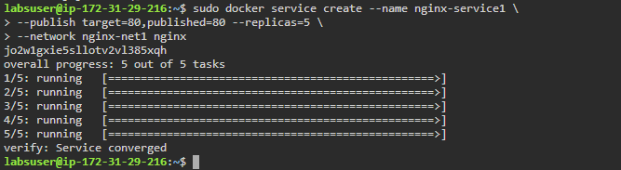

* List all the service tasks created by the replicated service

*sudo docker service ls*

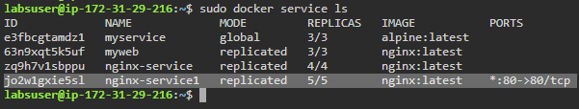

* Inspect the **nginx-net1** network on **manager** node and check the **Containers** section for the service tasks connected to the overlay network from this host

*sudo docker network inspect nginx-net1*

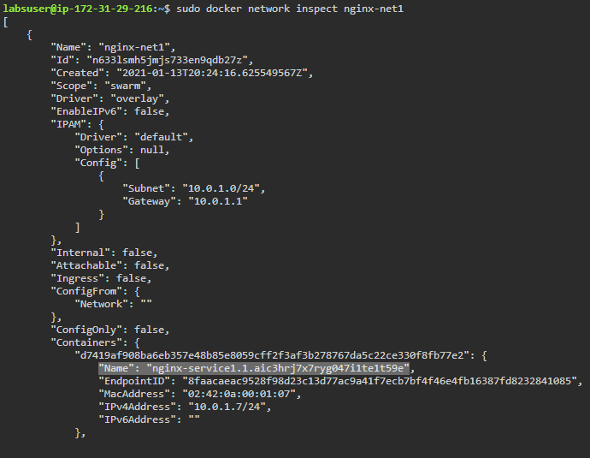

* Click on the **worker1** tab and navigate to the newly opened tab of worker1
* Inspect the **nginx-net1** network on **worker1** node and check the **Containers** section for the service tasks connected to the overlay network from this host

*sudo docker network inspect nginx-net1*

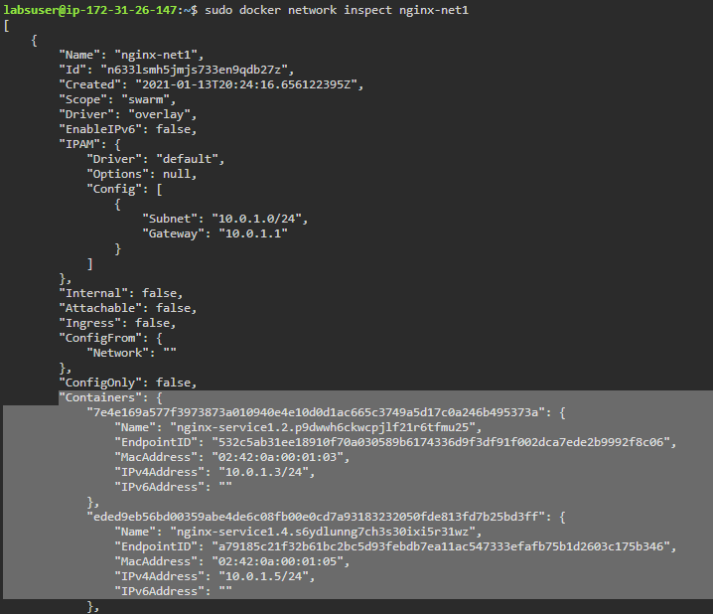

* Click on the **worker2** tab and navigate to the newly opened tab of worker2
* Inspect the **nginx-net1** network on **worker2** node and check the **Containers** section for the service tasks connected to the overlay network from this host

*sudo docker network inspect nginx-net1*

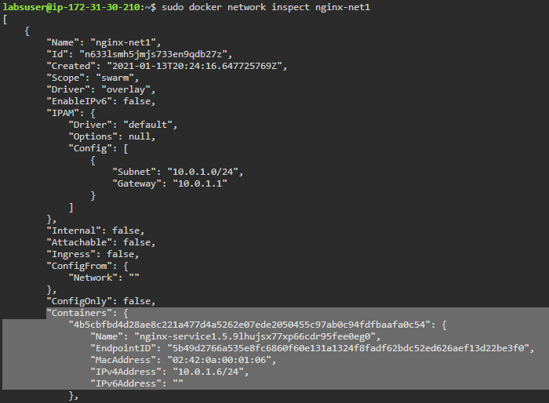

**Note:** Navigate back to the **master** tab to run commands on manager node.

* On the manager node, inspect the replicated service and check the **Ports** under the **Endpoints** section

*sudo docker service inspect nginx-service1*

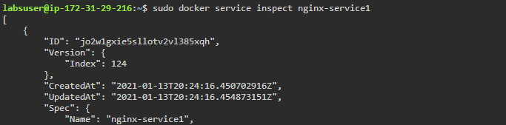

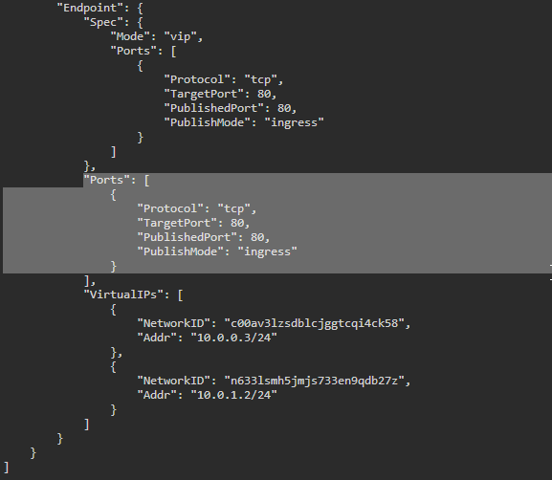

* Run the following command on manager node to clean the replicated service and network:

*sudo docker service rm nginx-service1*

*sudo docker network rm nginx-net1*

